

|  |
| --- |
| Ryan Bennett11/2019 Is Milwaukee the new Portland?  Subtitle |
|  |

|  |  |  |
| --- | --- | --- |
| MKE vs PDX  Subtitle | |  |
| 01Portland Statistics / Clustering02Milwaukee Statistics / Clustering03Comparison | I live in Milwaukee and for business I have traveled to the west coast quite a bit, specifically to Portland.  I remember running across this article:  <https://www.salon.com/2014/08/20/milwaukee_is_the_new_portland_partner> and wondering - is this really true? They do feel similar, but what does the data say? Do they have similarities in the make-up of their neighborhoods?  This project will explore similarities and differences of the distinct make-up of both cities at the neighborhood and city-wide level by describing and clustering neighborhoods by venue types using a K-Means clustering algorithm and exploring the frequencies of occurrence of discrete venue types. We will compare and contrast the results of our findings.  We will be exploring the neighborhoods using a combination of FourSquare's APIs for venues and locations with a combination of open source datasets to define our neighborhoods.   * <https://en.wikipedia.org/wiki/List_of_neighborhoods_of_Milwaukee> - we will use this list as the index of neighborhoods in Milwaukee * <https://portlandneighborhood.com/portlandzipcodes> - we will use this data to identity and come up with centroids for our Portland neighborhoods * <https://developer.mapquest.com/documentation/open/geocoding-api/address/get/> -open source geocoder | |

|  |
| --- |
| Portland Statistics/ClusteringTale of the tape – US Census Statistics Population: 653,115  Population / sq mile: 4375  Land area sq mile: 133  Number of businesses: 75583  Median household income: $61532 Portland Neighborhood Clustering – Methodology and Results To get a baseline of how Portland looks in terms of the venue makeup of its neighborhoods, we will run a K-Means clustering algorithm on a dataset that describes the neighborhoods in the way of venue frequency. |
| We end up with settling on 6 clusters after using the elbow method to determine the ideal number. |

The six clusters created seem to indicate a fairly homogenous dataset. Cluster 1 simply includes Argay:

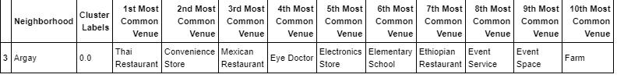

Cluster 2 contains 77(!) neighborhoods with nearly no cohesive properties other than coffee shops/bars.

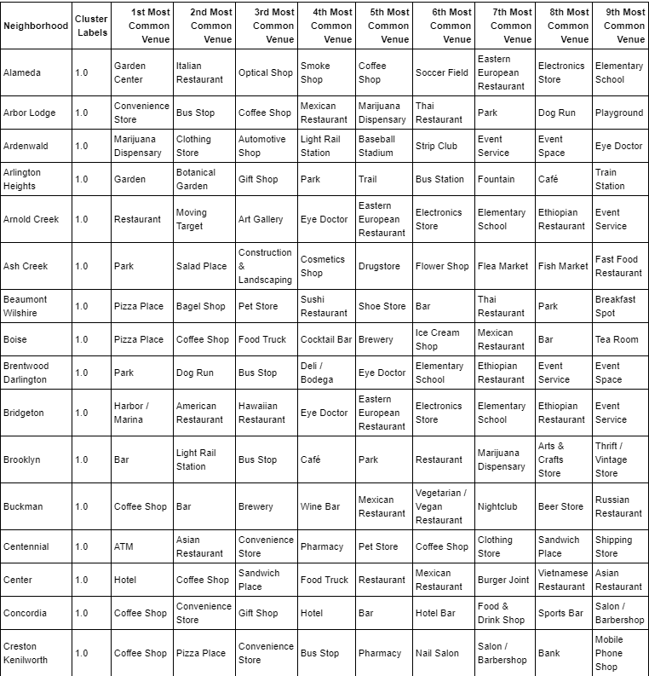

Cluster 3 is very cohesive and contains neighborhoods with heavy Park or Zoo presence.

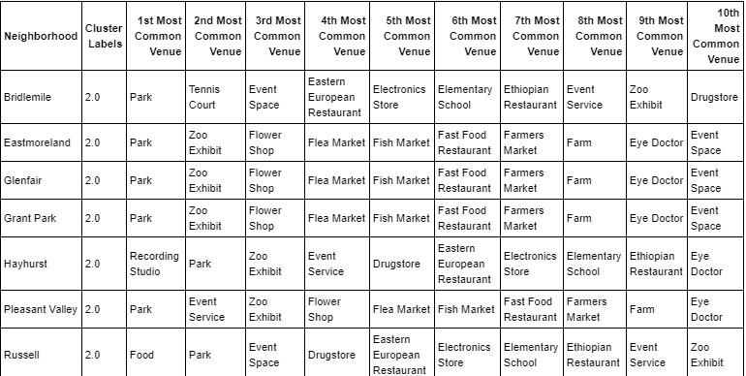

Clusters 4,5,6 all contain only a single neighborhood each.

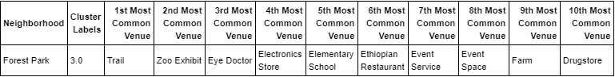

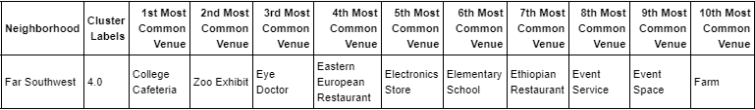

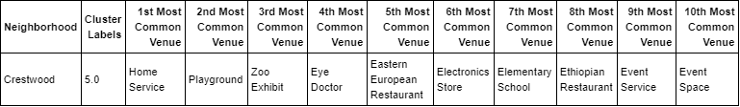

Portland seems to be very homogenous in terms of overall venue diversity in its’ neighborhoods with some neighborhoods being built specifically to house parklands.

# Milwaukee Statistics/Clustering

### Tale of the tape – US Census Statistics

Population: 592025

Population / sq mile: 6188

Land area sq mile: 96

Number of businesses: 38017

Median household income: $38289

## Milwaukee Neighborhood Clustering - Methodology and Results

To get a baseline of how Milwaukee looks in terms of the venue makeup of its neighborhoods, we will run a K-Means clustering algorithm on a dataset that describes the neighborhoods in the way of venue frequency

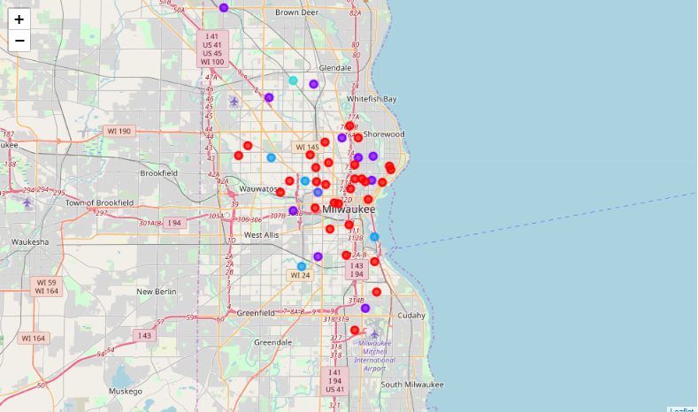

Milwaukee seems to have more distinction in it’s neighborhoods than Portland.

Milwaukee’s data seem best suited for 5 clusters using the elbow method.

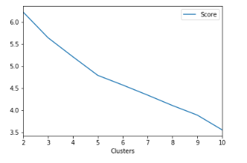

Milwaukee had a different feel to it’s clustering than Portland. Cluster 1, while large (30), seemed to be the least harmonious cluster with no real discernable topic.

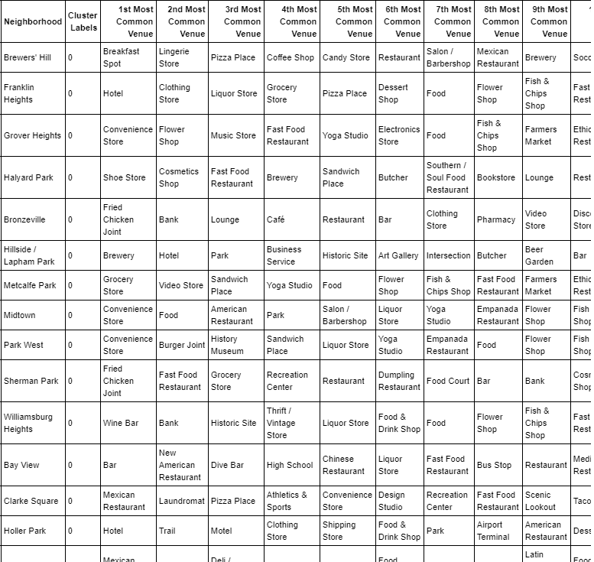

Cluster 2 clearly was focused on neighborhoods with high frequencies of bars.

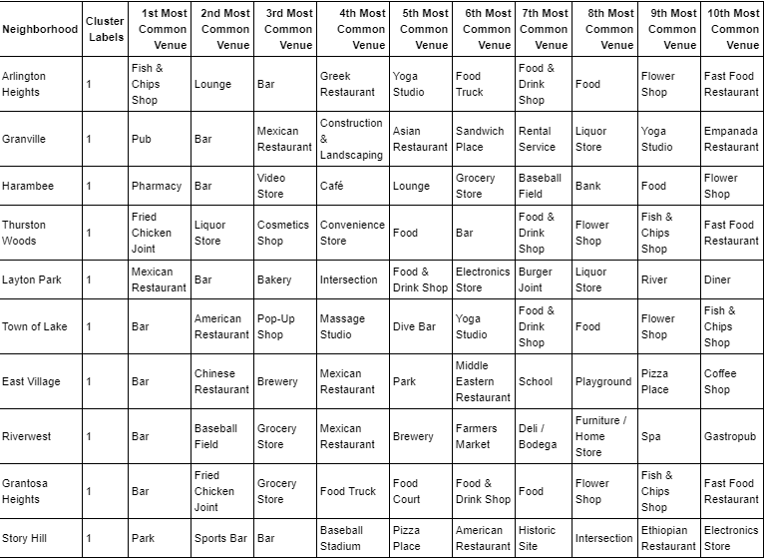

Skipping ahead to Cluster 4, this was clearly focused on parks/playgrounds.

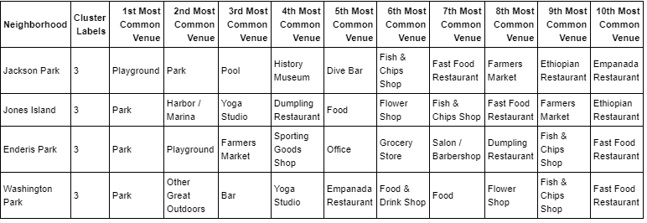

Clusters 3 and 5 stood alone

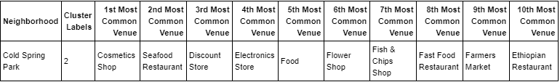

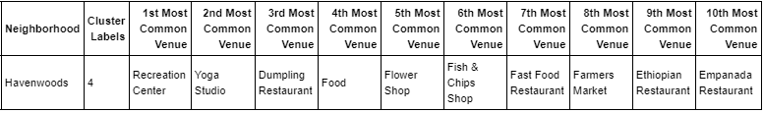

# Comparison – Discussion and Conclusion

Running a clustering algorithm on a combined data set of PDX and MKE neighborhoods did not show any interesting insight – a single cluster containing 90% of the neighborhoods was created and another cluster of neighborhoods featuring parks was also created. The rest were stand-alone PDX neighborhoods. You could argue that this shows that the cities are similar in that their neighborhoods are very distinctive and have their own flare/flavor – so much so that it is difficult to categorize most of the neighborhoods at all.

I did run a venue frequency analysis on both cities and found that the overall make up of both cities is radically different.

Highest avg frequency PDX venues:

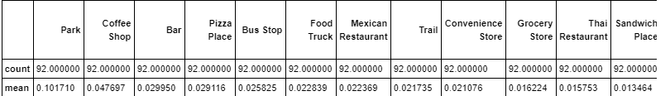

Highest avg frequency MKE venues:

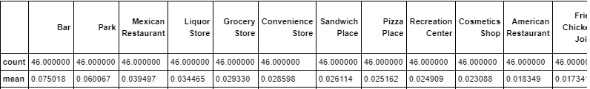

I think a fair conclusion to make here is that the cities are only similar in terms of population and geographic size but in terms of venues and neighborhood make up they are drastically different. There is no evidence to support that these cities share any sort of cultural connection beyond dedication to parks.